**Name: Debjyoti Sarkar Sumonta**

**Student ID: 22341019**

**CSE370 Section 2**

**Task 1:**

SELECT customer.customer_name, loan.loan_number

FROM

(loan INNER JOIN borrower ON loan.loan_number = borrower.loan_number)

INNER JOIN customer ON customer.customer_id = borrower.customer_id

WHERE loan.branch_name = 'Downtown';



**Task 2:**

SELECT c1.customer_name,c2.customer_name,c1.customer_city FROM

(customer c1 INNER JOIN customer c2 ON c1.customer_city = c2.customer_city)

WHERE c1.customer_id != c2.customer_id;



**Task 3:**

SELECT tempTable.branch_name as Branch_name,

tempTable.totalBalance * 0.04 as Total_Interest

FROM (SELECT SUM(balance) as totalBalance,branch_name FROM

account GROUP BY branch_name) as tempTable;



**Task 4:**

SELECT account.account_number,tempTable.branch_name,tempTable.balance FROM

(SELECT account.branch_name,MAX(balance) as balance FROM

(account INNER JOIN branch ON account.branch_name = branch.branch_name)

GROUP BY account.branch_name) as tempTable

INNER JOIN account

ON (tempTable.branch_name = account.branch_name AND tempTable.balance = account.balance);

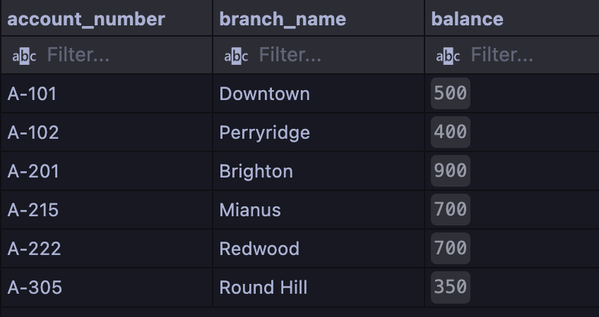

**Task 5:**

SELECT tempTable.loan_number as loan_number, tempTable.amount as loan_amount, customer.customer_name as customer_name FROM

(SELECT loan.loan_number, amount,customer_id FROM loan

INNER JOIN borrower ON loan.loan_number = borrower.loan_number

ORDER BY amount DESC LIMIT 5) as tempTable

INNER JOIN customer ON tempTable.customer_id = customer.customer_id

ORDER BY tempTable.amount ASC, tempTable.loan_number DESC;

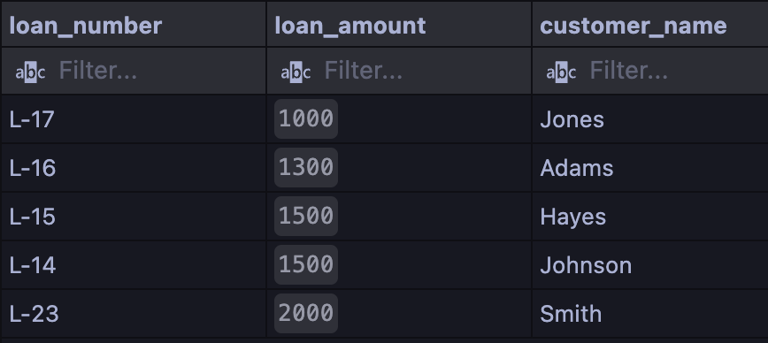

**Task 6:**

SELECT customer_name,amount

FROM (customer INNER JOIN borrower

ON borrower.customer_id = customer.customer_id)

INNER JOIN loan

ON loan.loan_number = borrower.loan_number

WHERE loan.branch_name = "Perryridge";



**Task 7:**

SELECT customer.customer_name,newTable.total_loan FROM

(SELECT borrower.customer_id,SUM(amount) as total_loan FROM

((borrower INNER JOIN

(SELECT customer_id,COUNT(*) as customerNumber From borrower

GROUP BY customer_id HAVING customerNumber >= 2) as tempTable

ON borrower.customer_id = tempTable.customer_id)

INNER JOIN loan ON borrower.loan_number = loan.loan_number)

GROUP BY borrower.customer_id) as newTable INNER JOIN customer

ON newTable.customer_id = customer.customer_id;

